TASK 1 — Create Main Loop and Display Prompt
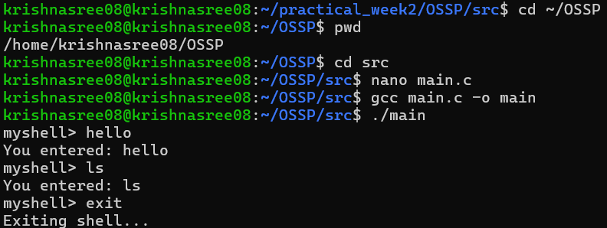
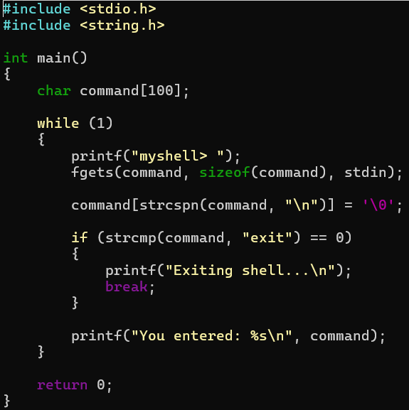

Summary
A basic interactive shell loop was created. The program displays a prompt, accepts user input, processes commands, and exits when the user enters exit. The task focuses on creating the main loop, displaying the prompt, reading input, and handling exit conditions.
Result
Thus, the basic interactive shell loop was successfully implemented and tested.
TASK 2 — Copy File1.txt to File2.txt Using System Calls
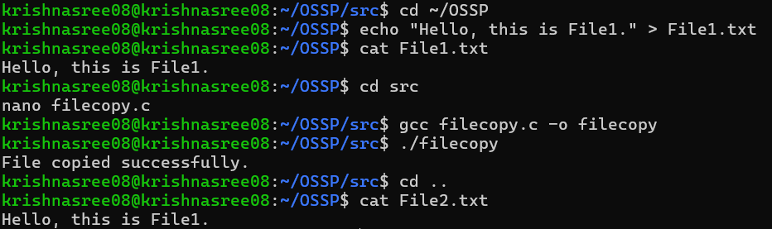
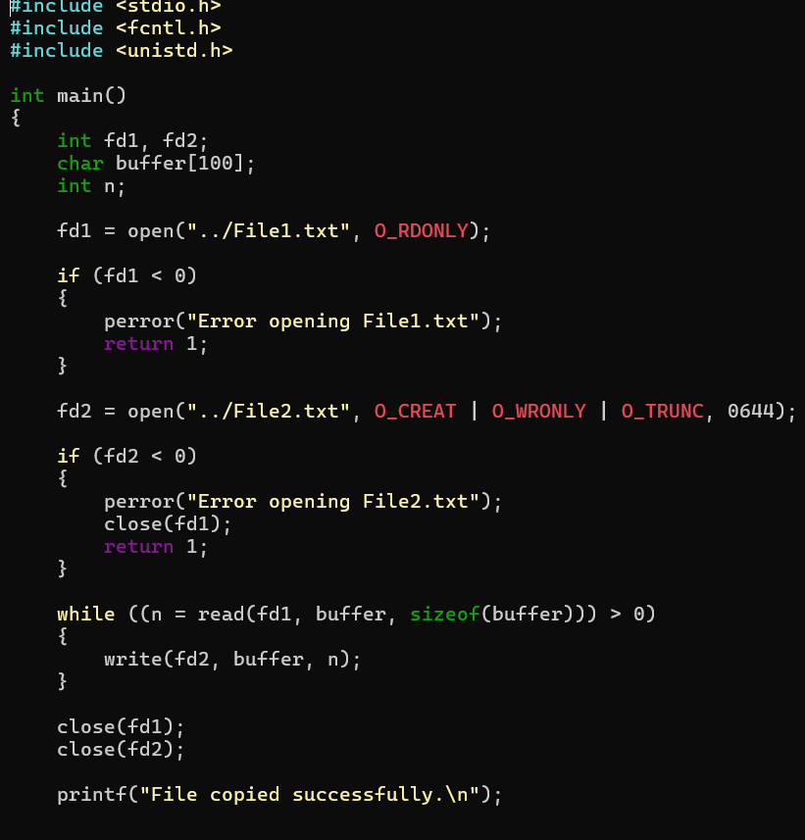
Summary:
A C program was developed to copy the contents of File1.txt to File2.txt using the open(), read(), write(), and close() system calls.
Result:
Thus, the contents of File1.txt were successfully copied to File2.txt using Linux file system calls.
TASK 3 — Capture Keyboard Input and Handle Backspace
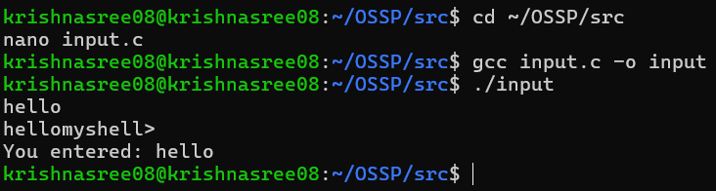
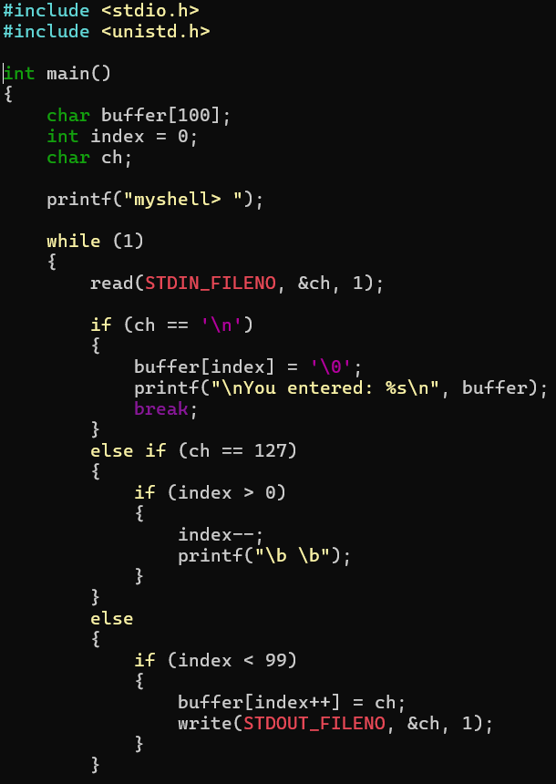
Summary
Keyboard input was captured character-by-character using the read() system call. The program manages an input buffer, handles backspace, processes the Enter key, and supports multi-character commands.
Result
Thus, keyboard input and basic editing functionality were successfully implemented.
TASK 4 — Command History
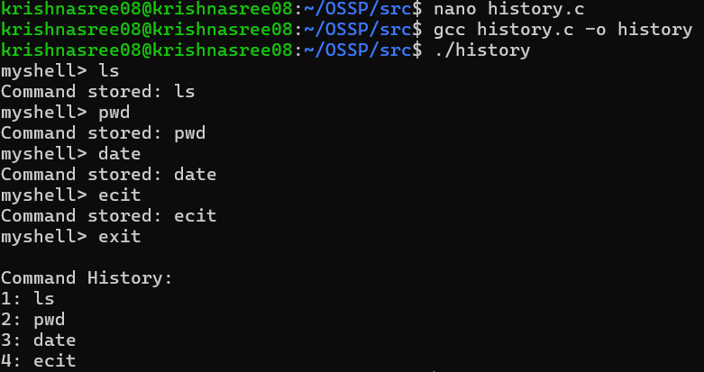
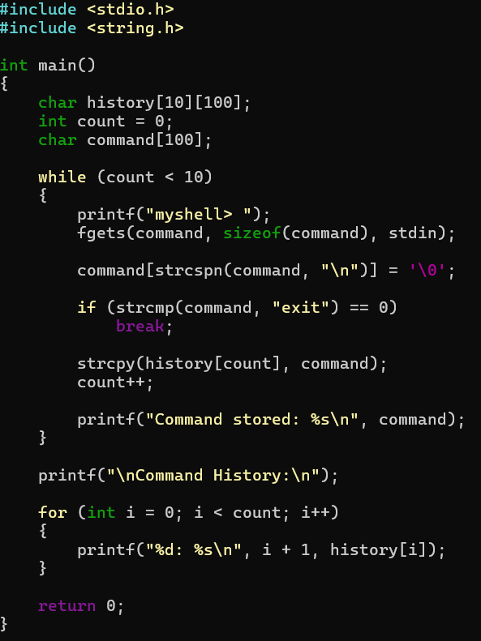
Summary
A command history mechanism was implemented to store previously entered commands and display them when required. The task focuses on command history storage, navigation, input-buffer updates, and recall functionality.
Result
Thus, command history storage and recall functionality were successfully implemented and tested.
TASK 5 — Dynamic Memory and Valgrind
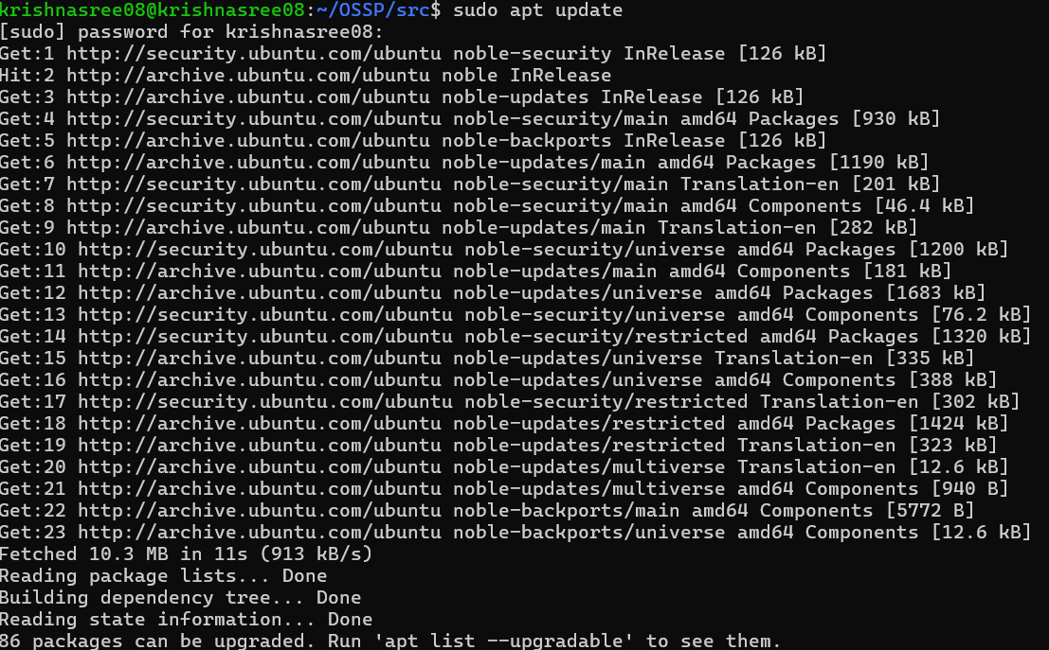
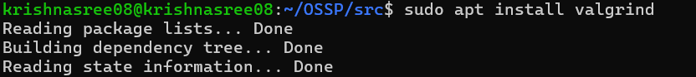
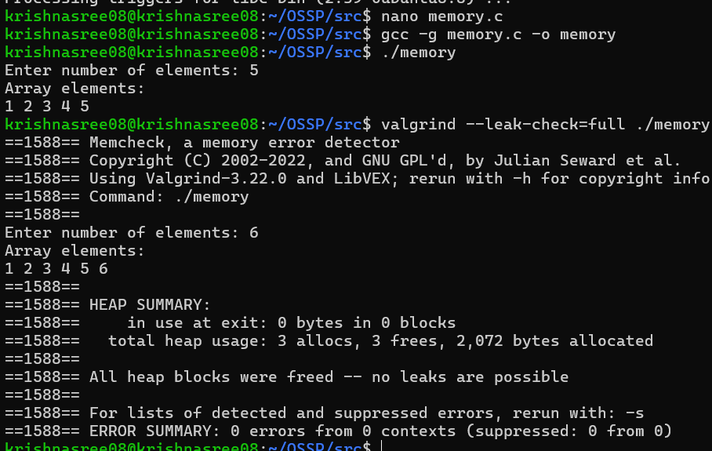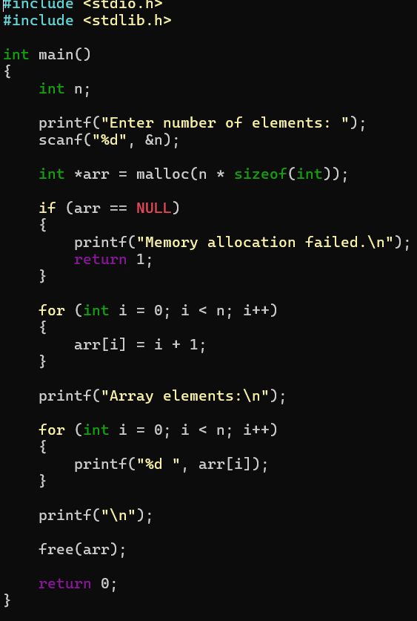
Summary
Dynamic memory allocation was implemented using malloc() and memory was released using free(). The program was validated using Valgrind to check for memory leaks and ensure that dynamically allocated memory was properly released.
Result
Thus, dynamic memory allocation and deallocation were successfully implemented and validated using Valgrind.

